Life on the edge: industrial footprint and edge effects variably influence the spatial distribution of a boreal small mammal

Aidan Brushett*¹, Emerald Arthurs¹, Jason T. Fisher²

* Corresponding author. Email: aidanbrushett@uvic.ca

¹ Equal co-authors; School of Environmental Studies, University of Victoria, Victoria, Canada
² School of Environmental Studies, University of Victoria, Victoria, Canada

Abstract

Wildlife distributions are entrained by the integration of biophysical processes operating across spatial scales and levels of ecological organization. In the Boreal Plains of Alberta, Canada, development from the energy and timber industries is dramatically restructuring western boreal landscapes by altering both the composition and configuration of wildlife habitat. Our study examines how landscape structure at multiple spatial scales influences the distribution of the North American red squirrel, a species closely tied to mature, cone-producing forest. Using data from 430 camera-traps across 10 boreal landscapes from 2021 to 2024, we measured the relative abundance of squirrels across a gradient of anthropogenic disturbances characterized by seismic lines, cut blocks, well pads, roads, and other industrial facilities. We used multi-model selection to compare the relative influence of disturbance composition and configuration metrics such as edge density, connectivity, and patch size on red squirrel detections. Red squirrel abundance was best explained by natural habitat characteristics on local spatial scales but had a negative relationship with anthropogenic edge density on larger scales. Edge density interacted with cumulative site disturbance such that edge effects were more strongly negative in heavily disturbed landscapes. We suggest that this pattern may be due to population-level shifts arising from increased encounters with mammalian and avian predators at forest edges. Anthropogenic disturbances that create a high amount of edge habitat, especially low impact seismic lines, may have a disproportionately negative impact on red squirrels that exceed predictions based on habitat composition alone. Our findings highlight the necessity of considering both habitat composition and spatial configuration on appropriate spatial scales when assessing wildlife responses to landscape change.

Keywords: Red squirrel, Tamiasciurus hudsonicus, landscape structure, Boreal Plains, oil and gas, edge effects, camera trap, wildlife distribution, seismic lines, landscape configuration

Introduction

Human-caused alteration of landscapes is a dominant driver of changes to biodiversity globally (Johnson et al., 2017; Maxwell et al., 2016). As natural resource extraction, agriculture, and urban expansion encroach on wild spaces, wildlife are increasingly displaced or forced to compete for space with anthropogenic activities (Johnson et al., 2017; Shackelford et al., 2018). Uncovering the ecological mechanisms that drive this process, however, is a long-standing and pressing challenge facing ecologists. Landscapes are complex, multi-scale matrices of habitat, resources, energy, and organisms (Lawton, 1991; Forman & Godron, 1981). Wildlife distributions are entrained by the integration of individual and population responses to biophysical processes across multiple spatial scales (Levins, 1992; Holling, 1992). Both the configuration and composition of landscapes, collectively deemed landscape structure (Pulliam? Godron?), exert a strong influence on local wildlife abundance—variations in either habitat amount or spatial patterning of habitat patches can lead to markedly different distributions of organisms, ecological processes, and community structures (Dunning et al., 1992; Tscharntke et al., 2012), providing a lens through which to understand disturbance effects on wildlife.

In terrestrial systems, anthropogenic disturbances change landscape structure through multiplex changes to both composition and configuration. Natural resource development, for example, reduces the total amount of habitat available to wildlife, while also reconfiguring remaining habitat into smaller, more-isolated patches via fragmentation (Wilsom et al., 2016; Didham, 2010). The resulting mosaic of dissimilar habitat patches can further affect wildlife by influencing connectivity, edge habitat, resource availability, or predation risk (Haddad et al., 2015; Pfeifer et al., 2017; Kremsater & Bunnell, 1999). While the relationship between habitat amount and declines in terrestrial biodiversity is well established (Brooks et al., 2002), the independent, additional influence of landscape configuration is more contentious, with conflicting evidence for fragmentation effects presented across studies (see Fahrig, 2017; Fletcher et al., 2018; Martin, 2018). A critical challenge in determining the relative importance of each is that fragmentation is hierarchically connected to habitat loss in many real-world ecological systems: most habitat loss also results in net fragmentation (Didham et al., 2012; Ruffell et al., 2016). Yet, the differential ecological mechanisms of habitat loss and fragmentation have distinct consequences for the assembly and functioning of wildlife communities (Sousa, 1984; Swihart et al., 2006), and both must be evaluated in specific terrestrial systems when seeking to understand how human activities shape species distributions.

Few regions embody the challenge of understanding landscape structure more than the western boreal forest of North America. Western boreal systems are characterized by a naturally heterogeneous mosaic of vegetation and biophysical traits, including wetlands, aspen parkland, conifer lowland, and forests in a variety of successional stages (Kenkel et al., 1997). Although the boreal has been stewarded and developed by humans for generations (Lewis, 1982; Timoney, 2003), the Boreal Plains have undergone unprecedented structural changes in recent decades at the collective hands of the timber, mining, and energy industries. Superimposed on the naturally ‘patchy’ ecosystems of the Boreal Plains is a pervasive network of cut blocks, roads, seismic lines, well pads, and processing facilities dedicated to the extraction, refinement, and transportation of natural resources (Pasher et al., 2013; Pickell et al., 2015). Disturbances such as fire are essential processes that maintain the ecological organization of western boreal systems (Weber & Flannigan, 1997), but the cumulative effects of decades of industrial development have eclipsed the influence of any natural processes to create an unprecedented spatial reorganization of boreal habitat and resources (Pickell et al., 2015). Although energy sector disturbances constitute less than 2% of the footprint of Alberta’s boreal forest by area (Alberta Biodiversity Monitoring Institute, 2023), their high density and persistence have fundamentally transformed boreal landscape composition and configuration. For instance, over 1.8 million kilometers of seismic lines—long-lasting linear features used to map underground oil and gas deposits—stretch across the western boreal, producing disproportionate amounts of forest edge habitat, early-seral vegetation, and movement corridors through otherwise intact tracts of habitat (Dabros et al., 2017, 2018; Lee & Boutin, 2006).

Confronted by these novel landscapes, the resident wildlife of the Boreal Plains must contend with the vast footprint of natural resource industries (Venier et al., 2014). Virtually all boreal mammals have been impacted—positively or negatively—by anthropogenic activities in the western boreal (Curveira-Santos et al., 2024; Fisher & Burton, 2018; Wittische et al., 2021). Past research has heavily emphasized the effects of habitat and disturbance composition on boreal mammals, wherein changes in resource availability have evoked a multitude of complex changes to population sizes, wildlife behaviours, and trophic and competitive interactions among species (Burgar et al., 2019; Fisher et al., 2021; Fisher & Burton, 2018; McKenzie et al., 2012; Tattersall et al., 2020). The effects of landscape configuration in the western boreal have received comparatively little attention, despite emerging empirical evidence that boreal wildlife responses to changing landscape structure can exceed predictions based on habitat composition alone (Smith et al., 2024).

Discriminating the relative roles of habitat composition and configuration is critical for predicting outcomes wildlife outcomes in the Boreal Plains (Côté et al., 2016). Conceptual frameworks of fragmentation suggest that the importance of habitat configuration for wildlife populations varies non-linearly along a gradient of habitat availability, such that the ecological effects of fragmentation are most pronounced in landscapes that have low or intermediate amounts of suitable habitat (Andrén, 1994; Villard & Metzger, 2014; Didham et al., 2012). In the Boreal Plains, where levels of industrial land-use span large gradients, the effects of landscape structure are likely dependent on both spatial scale and characteristics of the habitat matrix. Thus, empirical studies that explicitly test species-specific relationships to landscape configuration and composition across spatial scales (e.g., Püttker et al., 2020) are critical to understanding the complete impacts of industrial development on boreal wildlife.

In this study, we present a case study of the North American red squirrel (Tamiasciurus hudsonicus) to investigate these concepts. Widespread throughout the Boreal Plains, red squirrels are seed predators whose dependence on mature, cone-producing conifer or mixed-forest ecosystems has been demonstrated across multiple spatial scales and ecozones (Fisher et al., 2005; Larsen, 2009; McDermott et al., 2020; Rusch & Reeder, 1978), representing an ideal model species for disentangling the role of landscape structure in western boreal systems. Natural and anthropogenic disturbances, including wildfire and timber harvesting, directly affect red squirrel habitat composition by removing key resources found in mature forest (Fisher & Wilkinson, 2005; Russel et al., 2010). Likewise, cleared anthropogenic features characteristic of energy industry infrastructure are unlikely to offer potential resource subsidies. The fragmentation of red squirrel habitat by industrial disturbances is an additional consideration that remains poorly understood—landscape structure has mostly been explored in the context of agricultural matrices (Bayne & Hobson, 2000; Patterson & Malcolm, 2010; but see Fisher et al., 2005). In boreal systems, oil, gas, and timber development can introduce changes to vegetation structure along forest edges (Harper et al., 2015; Jackson et al., 2023) that may decrease landscape permeability and red squirrel movement (Bakker & Van Vuren, 2004), affect squirrel behaviour (Anderson & Boutin, 2002), or influence the abundance (Tattersall et al., 2020) and functional responses (McKenzie et al., 2012) of co-occurring predators. Even in heavily disturbed landscapes, the cumulative footprint of seismic lines represents a small amount of habitat loss sensu stricto for red squirrels. A strict focus on the amount of environmental impact is likely to underestimate true ecological effects (Drabos, Pyper & Castilla, 2018) due to the high density of industrial features and accompanying reconfiguration of habitat. Explicitly testing the influences of composition and configuration on red squirrel distribution may yield valuable insights into the effects of landscape structure on ecological processes in rapidly changing Boreal Plains ecosystems more broadly.

Our specific objective was to investigate the degree to which habitat composition, anthropogenic disturbance composition, and configuration influence red squirrel distribution in the remaining habitat matrix of Boreal Plains landscapes, as well as the spatial scale of those effects. We hypothesized that: (i) both habitat loss and fragmentation from industrial development would influence red squirrel distribution, but (ii) the independent effects of habitat fragmentation would be greatest in landscapes where the amount of anthropogenic disturbance was high. To accomplish our objectives, we deployed 430 motion-activated cameras across the Boreal Plains that measured the relative abundance of red squirrels in landscapes with variable proportions and spatial patterns of forest habitat, seismic lines, cut blocks, and other industrial disturbances. We separately characterized landscape composition and configuration by determining the proportion of natural land cover or disturbance footprint in local landscapes, and derived three metrics representing the spatial pattern of habitat and disturbances: anthropogenic edge density, core habitat area, and cohesion (isolation) of remnant natural habitat. We expected that the relative abundance of red squirrels, as measured by detection rates on camera traps, would be highest in areas with a high proportion of mature conifer or mixed-wood forest relative to other natural habitat types. We also predicted that red squirrel relative abundance would be negatively related to the proportion of any cleared anthropogenic features (well pads, roads, and seismic lines). Finally, we expected that fragmentation effects (e.g., creation of anthropogenic edges or isolation of habitat patches) by industrial disturbances would have a negative, context-dependent relationship with red squirrel relative abundance, that was strongest in landscapes with high amounts of total disturbance.

Methods

Study area

The Boreal Plains ecozone spans 740 000 km² of the boreal forest in Treaty 8 Territory and encompasses a wide variety of vegetative land cover, climate, productivity, and human activity. The region is characterized by a mosaic of aspen parkland, mixed broadleaf, white spruce, and jack pine forest, black spruce lowland forest, as well as wetlands, muskeg, fens, and lakes. We studied ten landscapes (Figure 1) representing aggregations of 3–5 watersheds with a total area of 1000–3000 km² (Bayne et al., 2021) across the Boreal Plains. Landscapes spanned a gradient of low–high industrial development intensity and a variety of anthropogenic land-use types that included timber harvesting, open pit bitumen mining, and in situ oil and gas extraction. Common disturbance features included timber cut blocks, seismic exploration lines, well pads, roads, pipelines, and processing facilities (Figure 1) with varying degrees of human use or active restoration. Other common small- and medium-sized mammals in our study area included the American marten (Martes americana), fisher (Pekania pennanti), Canada lynx (Lynx canadensis), coyote (Canis latrans), snowshoe hare (Lepus americanus), and North American beaver (Castor canadensis), along with a diverse community of small rodents. Common avian predators of red squirrels included the northern goshawk (Accipiter gentilis) and great horned owl (Bubo virginianus).

Camera trapping and wildlife occurrence data

We deployed motion-activated camera traps within each of our ten landscapes between 2021 and 2024 with the intended purpose of monitoring red squirrels and other medium- to large-sized mammals up to the size of moose (Figure 1). Cameras were deployed using a constrained stratified sampling design. First, we divided landscapes into 2 km² hexagonal cells and randomly selected ~60 potential cells for camera deployment within strata corresponding to either upland forest (low moisture, >50% deciduous) and lowland forest (high moisture, >50% coniferous), or forest type (broadleaf, coniferous, and mixed). Camera placements in randomly-selected hexagonal cells were constrained to locations >100 m from roads and >1 km from neighbouring camera placements to maintain independent sampling. Infrared camera traps (Reconyx PC900 Hyperfire or Hyperfire II Professional; Holmen, WI, USA) were placed approximately 100 cm above the ground, facing a wildlife trail 3–7 meters away. To avoid confounding movement with habitat use (Stewart et al., 2018), cameras used in analyses were not directly deployed on human trails or seismic lines unless these features had clear wildlife signs. To maximize wildlife detectability, we applied a scent lure (O’Gorman’s Long Distance Call, MT, USA) once at each site at the time of deployment (either September or October). Camera traps were programmed to take photos continuously at high sensitivity when movement was detected within the field of view. A total of 430 cameras were deployed across the ten landscapes (mean 43 per landscape, range 36–50). Within the 2021–2024 sampling period, each camera was deployed for approximately one year (autumn to autumn; mean=347 days, SD= 67.2 days).

To quantify the occurrence of red squirrels in each landscape, all images of wildlife occurrences were reviewed and classified to the species level using the image processing software Timelapse 2.0 (Greenberg, 2019), then aggregated to identify independent detections of red squirrels. We defined independent detection events for red squirrels as those occurring >30 minutes apart at a given camera site. To create a response variable for statistical modelling, we binned red squirrel detections into monthly independent detections. We assumed that the number of monthly detections at each camera site represented a relative index arising from both the local abundance and intensity of site use of red squirrels at that site (Burton et al., 2015; Parsons et al., 2017). We treated non-detections as true absences and elected not to use occupancy models (McKenzie et al., 2002) for our statistical analyses. Any given sampling month was excluded from our final dataset when there were fewer than fifteen days of available camera-trap data.

Measuring landscape structure

We used the Alberta Biodiversity Monitoring Institute’s (ABMI) 2021 Human Footprint Index dataset (ABMI, 2021) to determine the amount and type of anthropogenic disturbance features across our study area, and Wulder’s et al. (2024) Satellite-Based Forest Inventory to measure forest structure, amount of vegetative land cover, and fire disturbance across our study area. To characterize landscape structure, we derived several variables describing the anthropogenic and natural features surrounding each camera site which we hypothesized a priori to be ecologically related to red squirrel relative abundance. Since habitat relationships arise on spatial scales that are taxa- and context-specific (Wiens, 1989; Jackson & Fahrig, 2015), we calculated all configuration and composition covariates at twenty-two spatial scales using concentric circular buffers of 50 m, 100 m, and 250–5000 m radii increasing by 250 m increments sensu Fisher et al. (2011). First, we measured landscape composition: this included the proportion of area around each camera site covered by each dominant land cover type (e.g., forest type, wetland, shrub) and recent (0–15 years) fire disturbance, as well as the proportion of area covered by anthropogenic disturbances (e.g., well pads, roads, timber harvest blocks 0–15 years old; Table 1). As a representation of total disturbance amount, we also calculated a cumulative site disturbance at each camera location, adapting the methods of Bayne et al. (2021) and summed the proportion of area covered by all anthropogenic disturbances. To measure landscape configuration, we superimposed and rasterized the Human Footprint Index on the Satellite Based Forest Inventory landcover types at a five-meter resolution and extracted four metrics which we hypothesized to correspond to potential mechanisms through which landscape structure affects the distribution of red squirrels (Table 1). Our configuration metrics included natural edge density, representing the total length of patch edges and boundary complexity created by anthropogenic features, effective mesh size, representing the average size of habitat patches and degree of fragmentation, cohesion, representing the connectivity of similar habitat patches, Shannon evenness index, representing dominance and how evenly different land cover types were distributed across the landscape. All covariates were processed using the sf, terra, and landscapemetrics packages (CITATIONS) in R v4.3.0 (R Core Team, 2023).

Statistical analysis

We modeled the spatial responses of red squirrels to landscape structure using a multi-step, information theoretic approach. For all statistical analyses, we used generalized linear mixed models with a negative binomial distribution to account for overdispersion of red squirrel detection data (Zuur et al., 2007). We opted against using a proportional negative binomial response due to the high overdispersion of red squirrel count data in our dataset and poor overall model fit during exploratory analysis. In each model we treated monthly independent detections as the response variable and included nested random intercepts of camera sites within arrays. Specifically, our models took the form:

detections_{ijk} ~ NegBin(μ_{ijk}, θ)
log(μ_{ijk}) = β₀ + β₁x_{1,ijk} + … + β_{n}x_{n,ijk} + u_{i} + v_{i(j)}

where μ_{ijk} is the expected count of independent detections of red squirrels at site i in array j during month k, θ is the overdispersion parameter of the negative binomial distribution, and v_{i(j)} and u_{i} are the nested random intercepts of site and array, which were assumed to have a normally-distributed variance.

All explanatory variables were scaled using standardized z-scaling to improve model convergence and interpretability of relative effect sizes. To test our ecological hypotheses about the relative importance of landscape composition and configuration on red squirrels, we first divided our explanatory variables into three categories corresponding to our ecological hypotheses: [i] composition of natural habitat, [ii] composition of anthropogenic features, and [iii] landscape configuration (Table 1). Since red squirrels may respond to different aspects of landscape structure at separate spatial scales (Fisher et al., 2005), we identified a best-fit scale within each category of predictors before testing our hypotheses. Specifically, within each of our three categories of predictors, we fit a model using all predictors at each of the twenty-two spatial scales (i.e., 50–5000m) and compared AICc scores across spatial scales to determine which one was best supported for statistical modelling. This approach allowed us to empirically evaluate the appropriate scales for modelling and flexibly incorporate the effect of natural habitat composition, anthropogenic composition, and landscape configuration on red squirrel distribution at separate spatial scales (described in results and Table ##).

We performed model selection on a set of candidate models that corresponded to our hypotheses about habitat amount, habitat configuration, and context-dependent effects of habitat configuration using a hierarchical approach. To test whether natural habitat composition alone could describe red squirrel distribution (i.e., no disturbance or configuration effects), we initially built a model with the best-supported covariates representing natural habitat amount only using stepAIC to reduce a global model of all fire and land cover type covariates (sensu Chow-Fraser et al., 2018). We deemed this our ‘core model’, and included these variables in all models moving forward. We then combined covariates from each of the three categories into a candidate model set describing our hypotheses about the effects of landscape structure on red squirrel distribution. We did not include roads in any models due to their high correlation with other anthropogenic disturbances (especially well sites and industrial facilities) at our selected spatial scale. Configuration metrics were highly correlated with variables for anthropogenic disturbance type—a common challenge for Boreal Plains research (e.g., Smith et al. 2024) and fragmentation research more generally (CITE)—so our candidate model set was not fully nested. Instead, we represented disturbance in any configuration models using interactions with the aggregate Cumulative Footprint Index (CFI) metric, which was not highly correlated with any configuration variables. Our seventeen candidate models allowed us to compare the importance of various components of landscape structure for red squirrel distribution in our study area. We ranked candidate models using AICc scores to compare the importance of various components of landscape structure for red squirrel distribution and identify a best-supported model (Burnham and Anderson, 2002). We treated any candidate models with ∆AIC <3 as well-supported and interpreted them accordingly. Model assumptions were verified using diagnostic plots of residuals vs. fitted values and collinearity among predictors was assessed using variance inflation factors (VIFs; Zuur et al., 2016). We will evaluate model performance by simulating 10,000 datasets of landscape structure and refitting our model to determine predictive accuracy (Zuur et al., 2016; to be completed after class). Model selection and top model diagnostics were performed using the MuMIn (Bartoń, 2024) and performance (CITE) packages in R v4.3.0 (R Core Team, 2023).

Results

In total, we gathered 149,273 camera trap-days of data and 683,259 images, producing 7,399 images and 4,747 independent detections of red squirrels. Red squirrels were detected at least once at 305 of 430 camera trap sites (naive occupancy = 0.709).

The first step of our analysis identified best-fit spatial scales for our three categories of landscape covariates at three separate spatial scales that had strong or moderate model support compared to other scales (Figure 2). Natural land cover predictors were included in models at a 100 m spatial scale, while composition of anthropogenic features and landscape structure were both included at much larger spatial scales (4250 m and 2250 m, respectively; Figure 2).

The highest performing ‘core’ natural land cover model variables included the proportion of conifer forest, mixedwood forest, broadleaf forest, and areas burned within 0–15 years. However, this ‘core model’ was not well-supported compared to models that included anthropogenic disturbance composition or configuration variables (Table 2). Red squirrel distribution was best explained by a model including natural land cover, edge density, cumulative site disturbance, and an interaction between edge density and site disturbance (AIC_{w} = 0.568, R²_{conditional}= 0.099, R²_{marginal} = 0.744; Table 3; Figure 3), supporting our hypothesis of disturbance-mediated configuration effects. Red squirrel detections were negatively related to the proportion of broadleaf forest (β = -0.51, SE = 0.12, p <0.001; Figure 4), positively related to the proportion of mixed wood forest (β = 0.16, SE = 0.09, p = 0.08), and unrelated to the proportion of conifer forest (β = -0.03, SE = 0.11, p = 0.771; Figure 4). The amount of recent fire had a weak positive effect on red squirrels (β = 0.158, SE = 0.11, p = 0.16; Figure 5). Overall, anthropogenic edge density had a weak effect on squirrel detections (β = -0.09, SE = 0.17, p = 0.59) that became much more strongly negative at high levels of cumulative site disturbance via an interaction term (β = -0.26, SE = 0.10, p = 0.01; Figure 6). Unexpectedly, the effect of cumulative site disturbance itself was the opposite of our predictions and had a positive effect (β = 0.30, SE = 0.12, p = 0.01; Figure 7).

Our top model had only moderate separation from the second-supported model (ΔAICc = 2.45, AIC_{w} = 0.156; Table 2), which included effects for the composition of all vegetated anthropogenic disturbance features except for timber harvesting. In this model, red squirrel detections were negatively related to the proportion cover of seismic lines (β = -0.45, SE = 0.13, p = 0.001), positively related to pipelines and transmission lines (β = 0.31, SE = 0.13, p = 0.02), and neutrally related to inactive well sites (β = 0.01, SE = 0.143, p = 0.97).

Discussion

The synergistic effects of landscape composition and configuration drive species distribution. As hypothesized and aligning with our conceptual framework, the overall amount of suitable habitat remaining caused fragmentation effects to increase; wherein as cumulative site disturbance increased, edge effects became more pronounced. Contrary to our hypotheses, the overall effect of cumulative site disturbance was positive. Within the study area, the highest amount of cumulative site disturbance was ~ 30% (i.e. > 70% of habitat remaining) therefore this only represents a moderate level of disturbance in which there are remaining intact forest patches. Strong negative impacts on species may not occur until less than 30% of suitable habitat remains (Andrén, 1994), therefore the landscapes included in this analysis did not exceed this threshold. Red squirrels may be resilient at low levels of overall disturbance and have been found at increased abundance in fragmented landscapes (Bayne & Hobson, 2000). Overall, our results show differential responses of red squirrels to disturbance features and highlight the importance of context dependency.

At our top modelled spatial scales, we found a negative influence of broadleaf forest, positive influence of mixed forest and a neutral effect of conifer forest. Broadleaf forests contain little resources for red squirrels and the association with mixed forest likely is related to resources, as red squirrels are conifer specialists but are opportunistic (Benhamou, 1996), and will utilize other resources such as berries and fungi (Fisher et al., 2005; Fisher & Bradbury, 2006). The neutral effect of conifer was unexpected, but may be an artifact of the lack of separation between lowland and upland forest given the large difference in utility to squirrels (cite??). Fire is an important process within boreal ecosystems and may increase production for species with serotinous cones (Weber & Flannigan, 1997), potentially explaining the slight positive effect on squirrels, given they have evolved to feed on serotinous cones (Smith et al., 2003). Prescribed burning (low-intensity fire) does not have an effect on squirrels when key habitat features are retained (Russell et al., 2010) and the positive impact could be driven by potentially due to opportunistic foraging (Fisher et al., 2005).

The effects modeled in our study were incorporated on drastically different scales, and as a result likely affected red squirrels at different individual- and population-level processes. The spatial scale that best explained red squirrel relationship to the composition of natural habtiat was 100 meters. Red squirrels respond to resource availability and habitat texture at fine spatial scales, matching their small body size and home range (Fisher, 1999) and indicate the intensity of site use by individuals (Rusch and Reeder, 1978). At this small scale, red squirrels are distributing and dispersing relative to resource quantity and quality, a spatial grain that is a function of size (Holling, 1992) and how the species perceives the landscape (Kotliar & Wiens, 1990). While a species response to landscape heterogeneity will be dictated by its perception of grain and extent (Kotliar & Wiens, 1990), population responses may be revealed at scales far beyond this perception.

In contrast to composition of natural habitat, the effects of anthropogenic disturbance composition and configuration were best explained at much larger spatial scales that exceed the range of perception of individual animals (4250 m and 2250 m, respectively) — representing patterns at the meso-scale (Holling, 1992). Although individual squirrels are not responding to the amount of disturbance, population processes are mediated at the larger meso-scales that are unrelated to individual perception. Anthropogenic disturbance may be affecting population processes such as dispersal, immigration and emigration, rather than individual resource selection (Pulliam, 1988). Similarly, Fisher et al., (2011) found a large-scale best explained squirrel response to land-cover type, representing a numerical population response rather than individual response. Local resources and landscape disturbance are simultaneously impacting red squirrel populations via separate mechanisms that operate at vastly different scales (Levin, 1992). Broadly, heterogeneity created by disturbance governs the distribution of predator species and resources across the landscape, which are interacting to shape red squirrel distribution. Ecological systems represent integration of spatial processes on multiple scales, variability and distributions must be studied at multiple scales and not just one (Levins 1992 can be cited here).

At a large spatial scale, we found that edge effects negatively affect red squirrel occurrence, which could be a reflection of decreased dispersal. Red squirrels dispersal is impacted by landscape structure (Hämäläinen et al., 2019), as they are generally averse to crossing open habitat (Bakker & van Vuren, 2003) and disperse less in younger stands (Larsen, 2009), which could be a possible mechanism to explain the negative effect of seismic lines, which introduce a large amount of edge. Seismic lines have shown a strong negative effect on squirrels (Skatter et al., 2020; Beirne et al., 2021). However, we note that pipelines and transmission lines were positive, and likely represent a similar challenge to squirrel dispersal. In addition, cohesion — a strong proxy for landscape connectivity and dispersal potential (Schumaker, 1996) — performed poorly, therefore, we are cautious of this interpretation of edge effects.

Alternatively, negative edge effects and the negative effect of seismic lines could be caused by changes to predator functional responses. It is well established that many boreal mammal predators use seismic lines for movement (McKenzie et al., 2012; DeMars & Boutin, 2017; Tattersal et al,. 2020; Dickie et al., 2020), which may provide opportunistic predation opportunities on small species (?), such as red squirrels. Predators interact with the landscape at a much larger scale due to their increased home range and body size (Fisher et al., 2011?), therefore may explain the large scale of response. Seismic lines may also create edge-mediated changes to predator-prey dynamics between squirrels and avian predators. However, we could not measure avian predators, such as the northern Goshawk (Larsen & Boutin, 1994), in this study, which are likely influential drivers of red squirrel distribution as they are a main prey species (Salafsky et al., 2007). Edge features may provide better line of sight into forested areas, potentially decreasing search time and increasing predator-prey encounters. Research has found that birds of prey used edges for perching (Mirski & Väli, 2021) in an agricultural landscape, however, red squirrel survival in edge habitat is not decreased (Anderson & Boutin, 2002).

Contrary to our hypotheses, cumulative site disturbance had a positive effect on red squirrel occurrence. This effect was mediated through the creation of edge habitat — the positive effect was diminished when high edge density was present. In other words, cumulative site disturbance has a positive effect unless it creates a high amount of edge habitat. These are collinear processes, therefore we interpret this result with caution as there are only specific scenarios in which cumulative site disturbance is high but edges are low. A potential driver of this effect is resource complementation; at low amounts edge habitat may increase productivity (???). High squirrel abundance was found in fragmented habitat compared to contiguous habitat (Bayne & Hobson, 2000), although the mechanism is unknown. Another explanation is an overall decrease in raptors within disturbed landscapes, which are threatened globally by habitat loss and fragmentation (Cruz et al., 2021). Our second supported model included a strong negative effect of seismic lines (refer to table/figure?) and this specific disturbance type introduces a very high amount of edge, especially gridded 3D seismic lines. Thus, although the cumulative site disturbance was net positive, specific disturbance types that introduce a large amount of edge could still have a negative impact, compared to features such as pipelines and transmission lines. In addition, there are likely differential effects and ecological mechanisms from different types of landscape disturbance that are not realised within this analysis and are impacting red squirrel response to the variables included.

Caveats

A small, fast moving species such as the red squirrel can be difficult to capture via camera traps and while our study design allowed for sufficient detection of squirrels, cameras were not specifically set up to capture small wildlife and at a spatial scale for large mammals. Although cameras were stratified across a gradient of disturbance, no cameras sampled directly on disturbance features. Our ‘core model’ may have been improved with better land cover data — the lack of distinction between upland and lowland forest likely obscured red squirrel response to conifer forest. In addition, camera traps do not reliably detect avian species, therefore we had no measure of predation rates or ability to detect changes in predation risk with regard to disturbance features. Activity or noise along features, for example some well pads or seismic lines are new while others are old and potentially have reduced edge effects.

Conclusions

- No one gives a shit about squirrels but they are interesting and underappreciated
- Multiplex
- Our work expands on Smith et al. (2024), which illustrated the effect of configuration on wildlife species
- This multi-scale modelling framework could be applied to other species / multi species to better-understand how ecological processes at multiple spatial scales entrain wildlife distributions (Holling, 1992 has a good call to action about this at the end).
- ***Disturbance affects everything from a moose to a squirrel. As wildlife management begins to emphasize a full network of stressors on an ecological community…. Appreciation for ecological effects on all members of the community at multiple levels of organization. Effects extend beyond predictions anticipated by considering habitat loss sensu stricto. Aidan has good citations to tie this back to wildlife management/ecosystem understanding in general.

Although there are arguably more pressing conservation focuses in the Boreal Plains than red squirrels, our results

“Configuration important, can have an effect on red squirrels that exceeds predictions based on habitat composition alone”
Paragraph 1a:
- Were the hypotheses supported? Partially
- We were correct in hypothesizing that there is an interaction but it was not the direction we thought, increasing negative effect of edges but positive CFI
- Does this align with conceptual framework re: fragmentation? Andren, Fahrig, Didham
  - Frame in terms of information in intro
- Curiously, against our expectations, CFI was positive
- We suggest that the highest levels of CFI in the study area (e.g. maximum 30% site disturbance) still only represent a moderate/intermediate level of anthropogenic disturbance and did not have the same negative impact as anticipated.
  - E.g. Andren 199X proposed 30% remaining habitat as a threshold
- Positive effect unless it creates a lot of edges
- This paints a much more complex story than we initially anticipated:
Paragraph 1b. “At our modeled spatial scales, our top model found ___ and ___.”
- Interpret our top model.
- Discussion of coefficient directions and why

Paragraph 2a. “The effects modeled in our study were incorporated on drastically different scales, and as a result likely affected red squirrels at different individual- and population-level processes. .
- Scale notes from Aidan + Emerald – drastically different scales
- Natural and disturbances affecting squirrels on different scales/population processes
  - Reflects resources on the local scale, intensity of space use by individuals
    - Cite other squirrel ecology papers
  - “Squirrels (like many small mammals) respond to resource availability and habitat texture at fine spatial scales, matching their small body size and home range (cite squirrel home range paper that links range size to a 100 meter scale).”
  - Local scale and meso scale etc. etc.
Paragraph 2b. Discuss the broader scale disturbance effects.
- Conclude that this scale which is way beyond perception of individual squirrels affects population processes.
- “though individual squirrels may not be responding to disturbance amount, population processes are mediated on the larger meso-scales”
- Broadly, patterns of disturbance affecting other species distributions and distribution of resources.
[Short] Paragraph 2c (or interspersed throughout 2a and 2b where appropriate). Invoke how it ties into previous boreal squirrel work (Fisher et al. 2011 in particular)
- Invoke how this ties into a large body of literature (e.g. Levins, King hierarchy, Pulliam & Danielson, Holling 1992**)

Paragraph 3: What are those population processes that are being affected?
- Pattern-describing study, can only hypothesize the ecological mechanisms that give rise to this pattern.
- 1. (this feels fuzzy and maybe like a bit of a stretch??). Edge effects could decrease dispersal rates/metapopulation structure (3–4 papers like crossing behaviour, NFLD barrier to squirrel dispersal, etc.) that have large-scale negative effects on squirrel abundance.
  - What is the max distance they will cover?
  - Dispersal up to 1600m in boreal habitats. Kemp and Keith 1970.
However, pipeline + transmission line was positive in our second model – despite likely presenting a similar challenge to squirrel movement
**Additional line of evidence against dispersal: cohesion is generally accepted as a strong proxy for connectivity/dispersal that is robust to dispersal types/the way the landscape is digitized, and it did not come out as important in any models
SO we are cautious to fully accept this mechanism as explaining our results.
- 2. Predator functional responses. Huge collection of OSM/boreal literature about predator community use of seismic lines (especially Algar/Tattersall papers). Opportunistic predation, better line of sight, etc. Doubt a huge relationship between predators and squirrel detections (good rebuttal for why we didn’t use preds as a response variable). Biggest culprit? Avian predators that we could not directly measure. Line of sight into forest from edges, steepened functional response/lower search time. Predators interacting with the environment at larger scales due to much larger mobility, HR size, etc., can invoke this in scale discussion (below). Edge-mediated changes to predator-prey dynamics between squirrels and avian predators.
  - Are there any papers that look at avian predation in fragmented landscapes?
  - https://zslpublications-onlinelibrary-wiley-com.ezproxy.library.uvic.ca/doi/full/10.1111/j.1469-1795.2010.00379.x

Paragraph 4: Contrary to our expectations, CFI had a positive effect when low edges, but was mediated through the creation of edge habitat–i.e. positive effect of CFI diminishes if high edge is present.
- Possible resource complementation? Negative effect on squirrel predators (e.g., large-scale reduction of raptors in disturbed systems?) Really not sure.
- No clue, ***BUT these specific scenarios with high CFI and low edges are not common in real boreal study systems. Our CFI and config metrics were correlated—the creation of larger human footprints almost invariably creates edge habitat.
- [from Aidan notes] “not all disturbances are made equal. Second-supported model showed a strong negative effect of seismic lines on red squirrels. This is supported by other literature (Skatter et al. and Beirne are good papers). Thus although the aggregate effect of total industrial disturbance was a net positive, specific disturbance types that introduce a high amount of edge—especially very thin linear features like seismic lines—could still have a negative impact on red squirrels and the differential effects/ecological mechanisms of different disturbances cannot be discounted.” Compared to pipeline/transmission line, which are not
- Seismic lines (2-6m) can be gridded in a 200 m pattern and so this represents a very considerable amount of edge creation for a low amount of footprint, especially compared to pipelines/transmission lines, which might be how these disturbances differ.

Caveats/future directions section:
- Better landcover data, upland/lowland distinction
- on/near/off feature sampling would help.
- No data on avian predators or predation rates
- Dont have any information on actually ‘activity’ on the disturbance features - ex. roads all treated the same whether they are busy vs inactive

Conclusion:
- No one gives a shit about squirrels but they are interesting and underappreciated
- Multiplex
- Our work expands on Smith et al. (2024), which illustrated the effect of configuration on wildlife species
- This multi-scale modelling framework could be applied to other species / multi species to better-understand how ecological processes at multiple spatial scales entrain wildlife distributions (Holling, 1992 has a good call to action about this at the end).
- ***Disturbance affects everything from a moose to a squirrel. As wildlife management begins to emphasize a full network of stressors on an ecological community…. Appreciation for ecological effects on all members of the community at multiple levels of organization. Effects extend beyond predictions anticipated by considering habitat loss sensu stricto. Aidan has good citations to tie this back to wildlife management/ecosystem understanding in general.
- “Configuration important, can have an effect on red squirrels that exceeds predictions based on habitat composition alone”

Aidan general thoughts:
- Red squirrels are resilient fuckers and can probably adapt to whatever the heck they want
Aidan thoughts on CFI being positive:
- Results only partially supported our hypothesis about when configuration matters most (Didham, Andren, etc.). Positive effect of CFI. We suggest that the highest levels of CFI in study area (e.g. maximum 30% site disturbance) still only represent a moderate/intermediate level of anthropogenic disturbance. At these low to intermediate levels, had a positive effect. Why?? Need to do some digging here before I feel comfortable making an interpretation. Heterogeneity? Resource complementation? Competitive advantage over other small mammals? Effect is only positive after controlling for the effect of anthro edges (can test this statistically****).
- However, must caution against assuming all disturbances are made equal. Second-supported model showed a strong negative effect of seismic lines on red squirrels. This is supported by other literature (Skatter et al. and Beirne are good papers). Thus although the aggregate effect of total industrial disturbance was a net positive, specific disturbance types that introduce a high amount of edge—especially very thin linear features like seismic lines—could still have a negative impact on red squirrels and the differential effects/ecological mechanisms of different disturbances cannot be discounted.
  - Vegetation structure and density of veg decrease resource availability? Edge effects of forest/canopy structure can extend 35-50 m into the forest (cite Jackson 2023).
  - Seismic lines can be gridded in a 200 m pattern and so this represents a very considerable amount of edge habitat creation for a low amount of cumulative disturbance!

Emerald thoughts on CFI/questions
- Impacts to squirrels predators?
- How do birds of prey respond to high CFI?
- If seismic is negative, is it the block features that are more positive?
- Does this level of disturbance improve cone production? Is there any evidence of differences in productivity of the landscape?

  - Could edges suffer from reduced cone production because of the abrupt change in vegetation structure?? Have to read those seismic papers (Davros; Jackson)
  - cumulative disturbances may reduce the densities of some predators (can cite OSM papers, need to find some other raptor ones)
  - Possible resource complementation? Squirrels often follow the boom/bust cycle of the spruce cone mast. Do disturbances (at these low/intermediate levels) provide some sort of complementary resource that helps them ride through the ‘bust’ and stabilize resource levels?

What is the mechanism for edge effects? Two possible explanations:
- This is a pattern-describing study so we can only begin to hypothesize about the exact ecological mechanisms driving this pattern.
  - 1. (this feels fuzzy and maybe like a bit of a stretch??). Edge effects could decrease dispersal rates/metapopulation structure (3–4 papers like crossing behaviour, NFLD barrier to squirrel dispersal, etc.) that have large-scale negative effects on squirrel abundance.
    - What is the max distance they will cover?
    - Dispersal up to 1600m in boreal habitats. Kemp and Keith 1970.
However, pipeline + transmission line was positive in our second model – despite likely presenting a similar challenge to squirrel movement, so we are cautious to fully accept this mechanism as explaining our results.
  - 2. Predator functional responses. Huge collection of OSM/boreal literature about predator community use of seismic lines (especially Algar/Tattersall papers). Opportunistic predation, better line of sight, etc. Doubt a huge relationship between predators and squirrel detections (good rebuttal for why we didn’t use preds as a response variable). Biggest culprit? Avian predators that we could not directly measure. Line of sight into forest from edges, steepened functional response/lower search time. Predators interacting with environment at larger scales due to much larger mobility, HR size, etc., can invoke this in scale discussion (below). Edge-mediated changes to predator-prey dynamics between squirrels and avian predators.

Aidan thoughts on scale:
Disparity of natural and disturbance spatial scales may reflect their importance to different biological processes that are a part of RESQ ecology. Ecological systems represent integration of spatial processes on multiple scales, variability and distributions must be studied at multiple scales and not just one (Levins 1992 can be cited here).
- 1. On a fine spatial scale, natural cover represents squirrel resource availability (cones, etc.). Explains strong aversion to broadleaf and positive to mixedwood and fire (can cite a couple papers about the value of low-intensity fire). Local resource availability is important and on this scale, squirrels are likely distributing in relation to resource availability (can invoke optimal foraging or especially ideal free distribution here).
  - Squirrels (like many small mammals) respond to resource availability and habitat texture at fine spatial scales, matching their small body size and home range (cite squirrel home range paper that links range size to a 100 meter scale). Theory that supports this is in Holling 1992 cross-scale morphology. “mammals of all trophic levels utilize resources in their foraging areas in the same way by measuring the spatial grain of habitat patches with a resolution defined as a function of their size”
  - Neutral effect of conifer probably because it includes lowland sites, which are frequently not sampled in squirrel studies (e.g., Fisher et al. 2005) and generally seen as less suitable habitat. Need to parse this into upland/lowland next time or for publication.
- 2. On a broad scale: disturbance and edge effects affect dispersal, connectivity, population processes on a larger scale that is not governed by the perceptual scale of individual animals.
  - On what Holling calls the mesoscales: “contagious disturbance processes such as fire, insect outbreak, plant disease, and water flow dominate the formation of patterns over spatial scales of hundreds of metres to hundreds of kilometres.”
  - SO IN SUMMARY: though individual squirrels may not be responding to disturbance amount, population processes are mediated on the larger meso-scales. Different scales = individual-level versus population-level processes or interactions with other species on large scales.
- Our results support the conclusions of Fisher et al. 2011. We can write a similar sentence to this one and acknowledge that our findings support this: “we hypothesize that landscape heterogeneity affects population processes such as dispersal, immigration, and emigration, rather than foraging (Pulliam 1988). Patch size, proximity, and heterogeneity drive population dynamics and determine probabilities of local population persistence at large scales.”

Emerald thoughts on scale:
- What aidan said
- Are there any processes on the ‘meso-scales’ that we can point to directly?

Aidan caveats:
- Cameras not set up for squirrels. Some challenges with detectability.
- Upland/lowland distinction.
- No measures of avian predators or rodents including microtines.
- Unknown mechanisms.
- Did not sample directly on disturbance features – all cameras were placed in forested land cover and thus the direct effect of harvesting is low. We measured the effect of these disturbances on squirrels in the remaining matrix of forest habitat, not the direct impact of timber removal like many other studies that have found a negative effect. Argue that for our purposes the effect of harvesting possibly didn’t extend beyond the boundary of cutblocks itself (does this contradict our conclusion about other disturbance features?). Cutblocks create very little edge habitat compared to linear features. Better sampling for this (e.g. ABMI’s on/near/off-feature camera placements are slay for this).

Should mention somewhere why it’s important to study squirrels. TBH not a big conservation concern, but a great case study and really underscores that boreal industry development has truly affected every species down to the size of a squirrel!!

Papers that could be cited:

Beirne et al. 2021. Multispecies modeling:
- Like 70% of variance in models was due to random effects (so our R^2 isn’t terrible!!)
- increase in squirrels following restoration of seismic lines
- Mounding height was positively related, and line density had a negative effect on squirrels
- Could this be cited to support that there could be some predation process impacted by seismic lines? Absolutely, also Tattersall et al. 2020 (shared use of seismic lines)
Schumaker, N.H. (1996), Using Landscape Indices to Predict Habitat Connectivity. Ecology, 77: 1210-1225. https://doi.org/10.2307/2265590
- Generic paper that can be invoked if we talk about landscape metrics and connectivity, cohesion in particular is well-supported here but weirdly it didn’t work for us (and was SO correlated with edge density but performed poorly in models). Maybe better as a methods paper.
Jesse E. H. Patterson, Jay R. Malcolm, Landscape structure and local habitat characteristics as correlates of Glaucomys sabrinus and Tamiasciurus hudsonicus occurrence, Journal of Mammalogy, Volume 91, Issue 3, 16 June 2010, Pages 642–653, https://doi.org/10.1644/09-MAMM-A-118.1
- number of patches, forest cover, mean proximity index, and distance to NN patches.
- Red squirrels only associated with basal area of conifers
- 2 and 3 km spatial scales worked best
- They don't report on it but mean nearest-neighbor distance did have an affect

Dabros 2017. Edge influence of low-impact seismic lines for oil exploration on upland forest vegetation in northern Alberta (Canada). https://doi.org/10.1016/j.foreco.2017.06.030
- Corroborates our idea that edge effects are (a) present and (b) important ecologically
- “Low impact seismic lines cause significant edge influence on ecological factors. Reduced herbaceous and non-vascular vegetation on lines, edges, and/or near edges.”
R.S. Jackson, J.M. Dennett, and S.E. Nielsen. 2023. Effects of oil sands disturbances on shrub and tree structure along forest edges in Alberta's boreal forest. Canadian Journal of Forest Research. 53(8): 642-653. https://doi.org/10.1139/cjfr-2023-0005
- This study provides evidence of edge effects from anthropogenic footprints associated with energy exploration on trees and shrubs in the boreal forest of Alberta. We found that edge sealing, conceptualized as a thickening of tall, woody vegetation growth at disturbance edges, was common to multiple disturbance types
- Effects observed up to 50m into the forest.
Walpole, A.A., Bowman, J. Patch occupancy by squirrels in fragmented deciduous forest: effects of behavior. Acta Theriol 56, 63–72 (2011). https://doi.org/10.1007/s13364-010-0010-0
- No effect of isolation/patch size on patch occupancy on ‘running’ species (i.e. red squirrels). Species-specific behaviours mediate effects – not consistent even among rodents
- Red squirrels are resilient fuckers
Skatter et al. 2020 squirrel and human activity. : Long-term Snow Track Monitoring to Understand Factors Affecting Boreal Forest Mammal Density in an Expanding In Situ Oil Sands Area.

Other notes:
- Monthly decreased overdispersion vs weekly occurrence frequency
- Quadratic harvest^2 improved AIC but barely changed coefficients or predicted effects, positive effect of harvest consistent across models.
- Remove outliers? Other students found AIC improvement but no change for coefficients
- OLD IDEA: separate sub-models for NATURAL COMP, ANTHRO COMP, CORE HABITAT, EDGE, COHESION would help with correlation (possibly) and provide more clarity on configuration mechanisms (e.g. disturbance relief, connectivity, edge effects)?
Interact anthropogenic edges with predator density??
5 | Tables and Figures we could possibly include (likely don’t want everything)

Table 1. Summary of covs
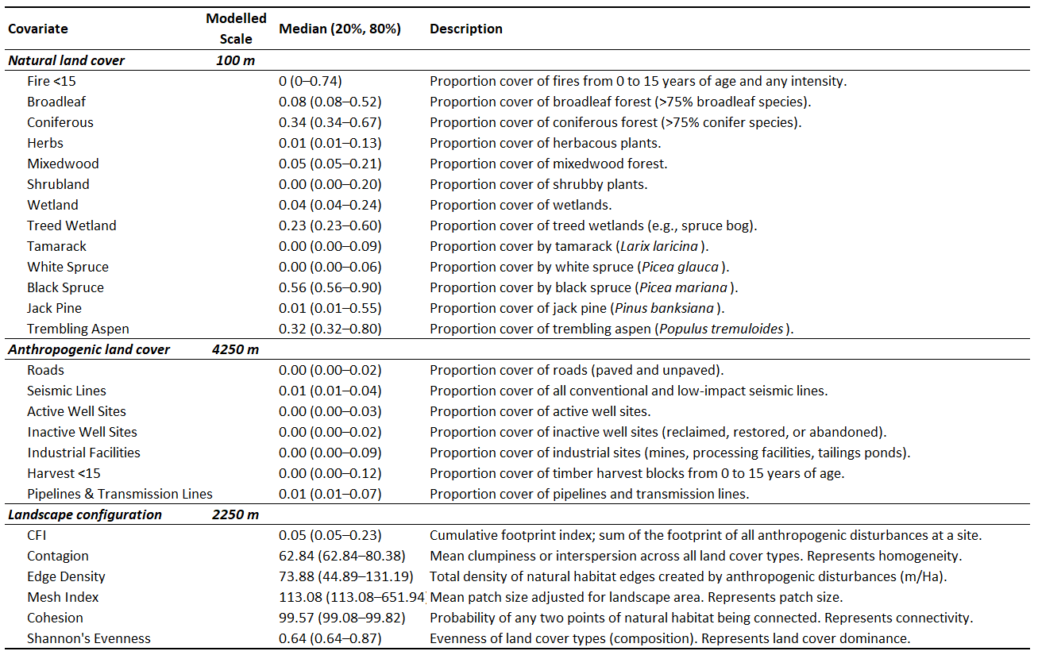

Table 2. Results of model selection. Bolded models within 3 AIC units
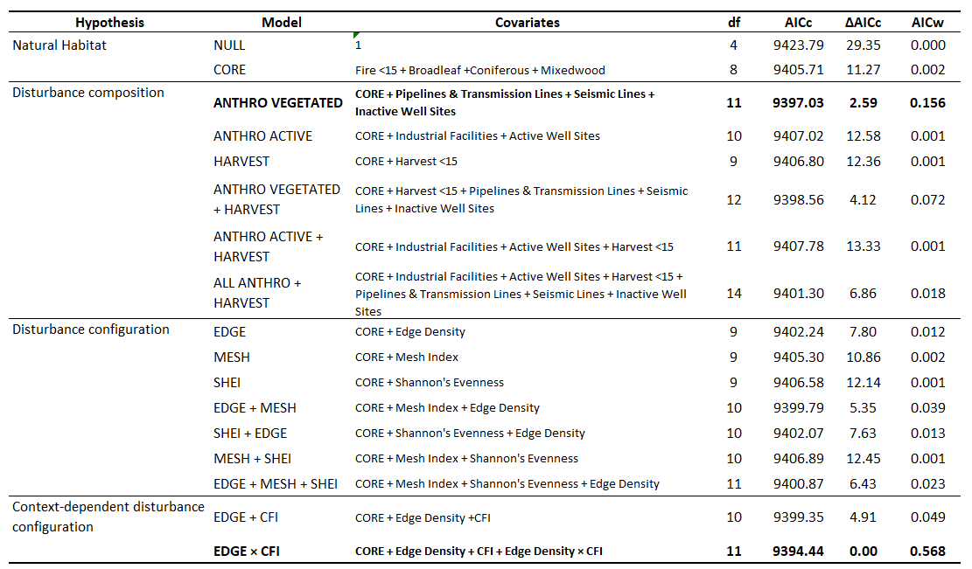

Table 3. Coefficient estimates for the top model (EDGE x CFI)
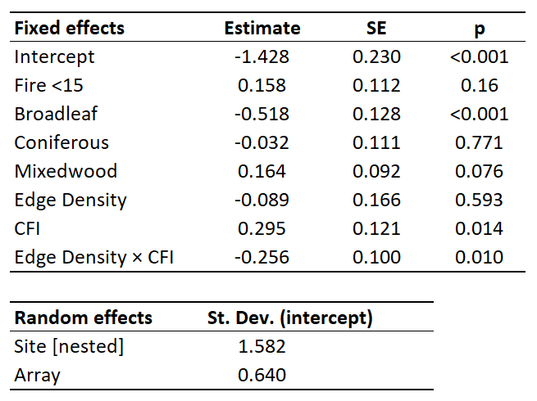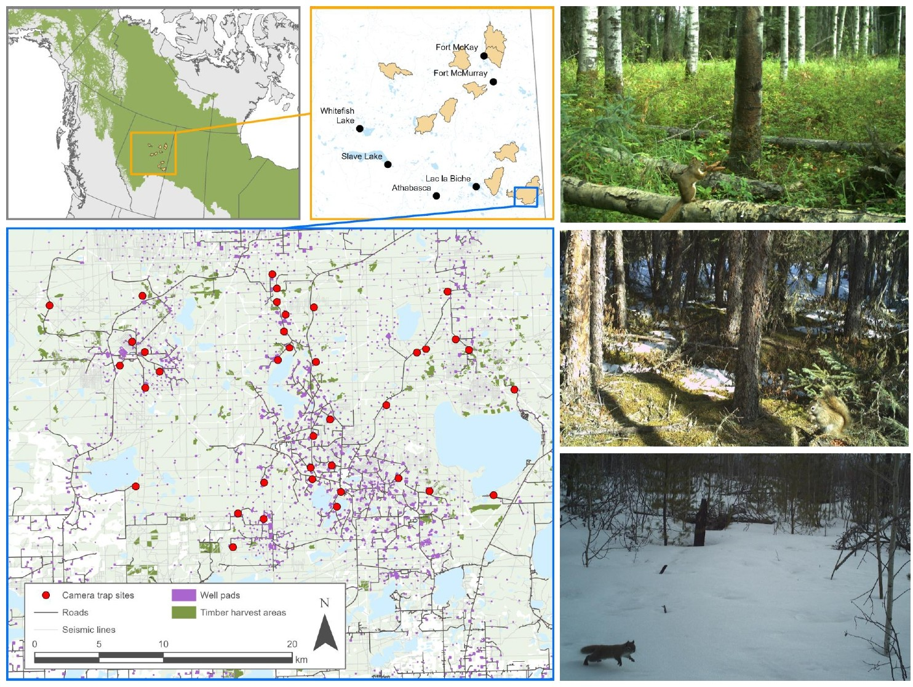
Figure 1. Ten landscapes within the Boreal Plains selected for sampling, representing a gradient of anthropogenic land-use and environmental traits. Camera trap placements within a given landscape followed a constrained stratified design based on vegetation characteristics. Red squirrels were detected year-round in a variety of habitat types (total independent detections = 4747).
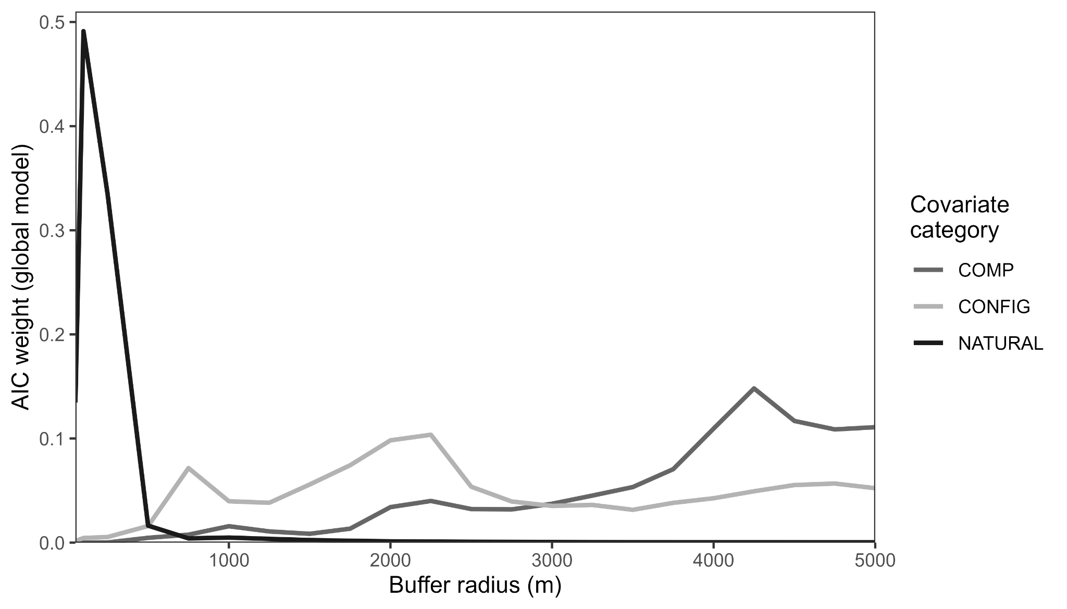
Figure 2. Top spatial scales as identified by scale analysis.

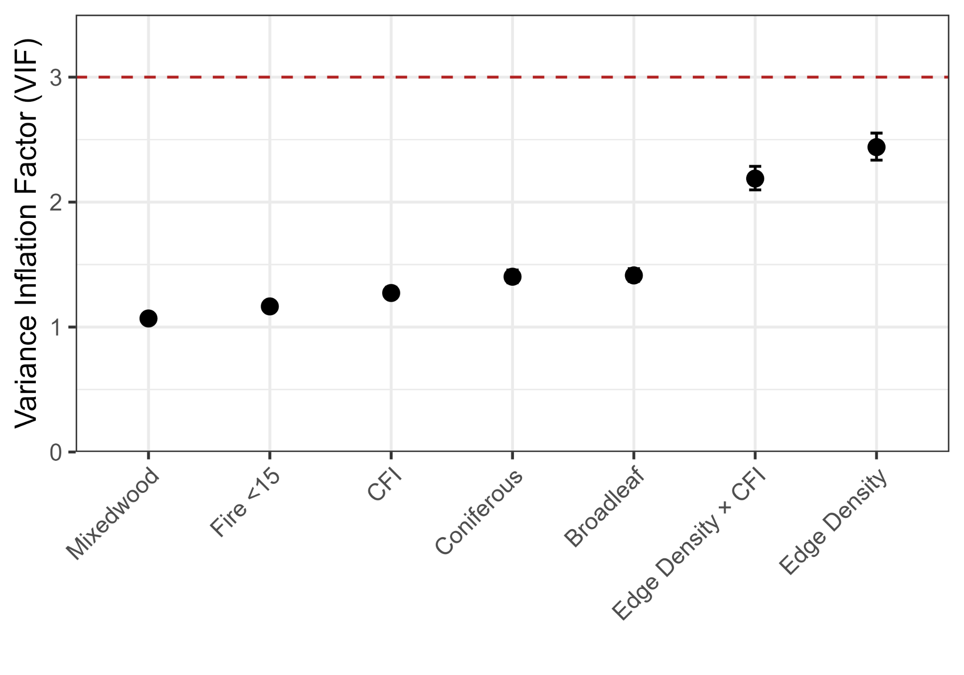
Figure 3. Variance inflation factors for the best-supported model.
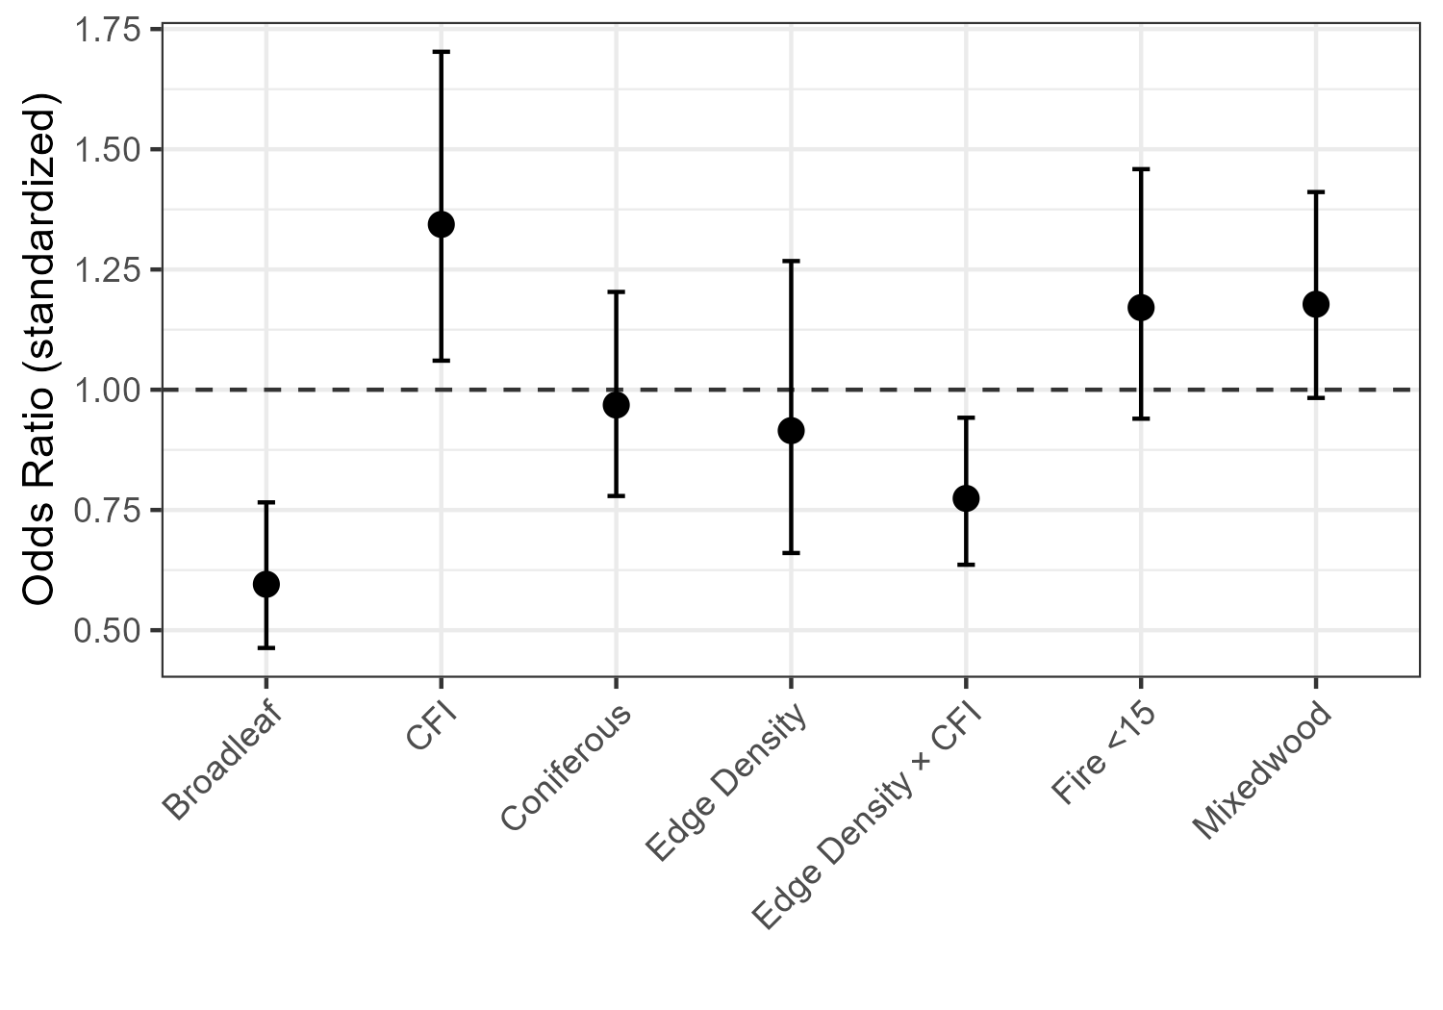
Figure 4. Odds ratios for standardized coeffs from top model.
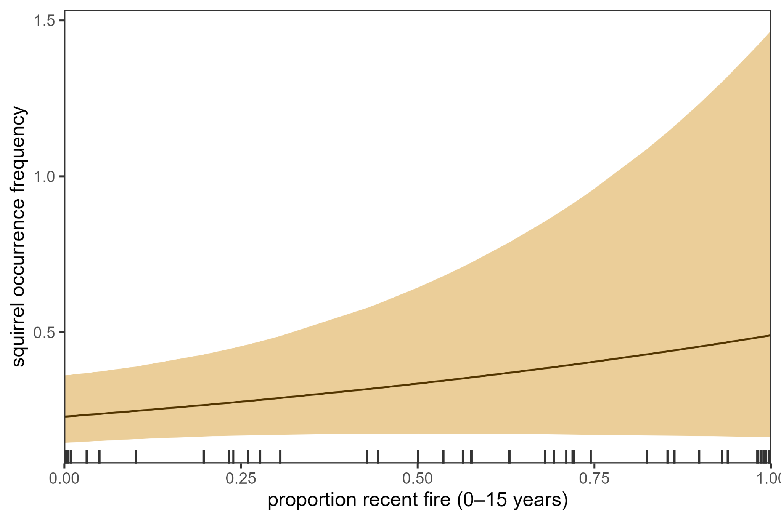
Figure 5. Conditional effect of recent fire disturbance on red squirrel detections.
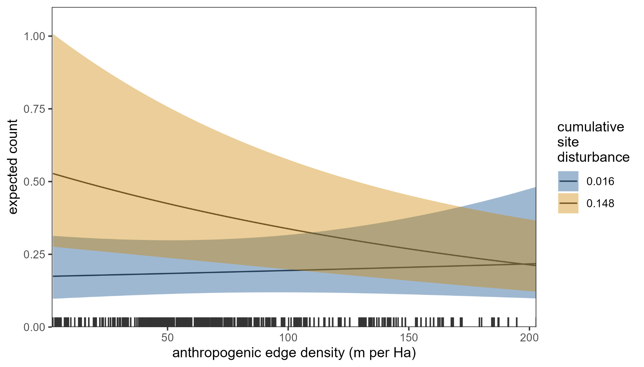
Figure 6. Conditional effect of anthropogenic edge density on red squirrel detections at high (90% quantile) and low (10% quantile) cumulative site disturbance.
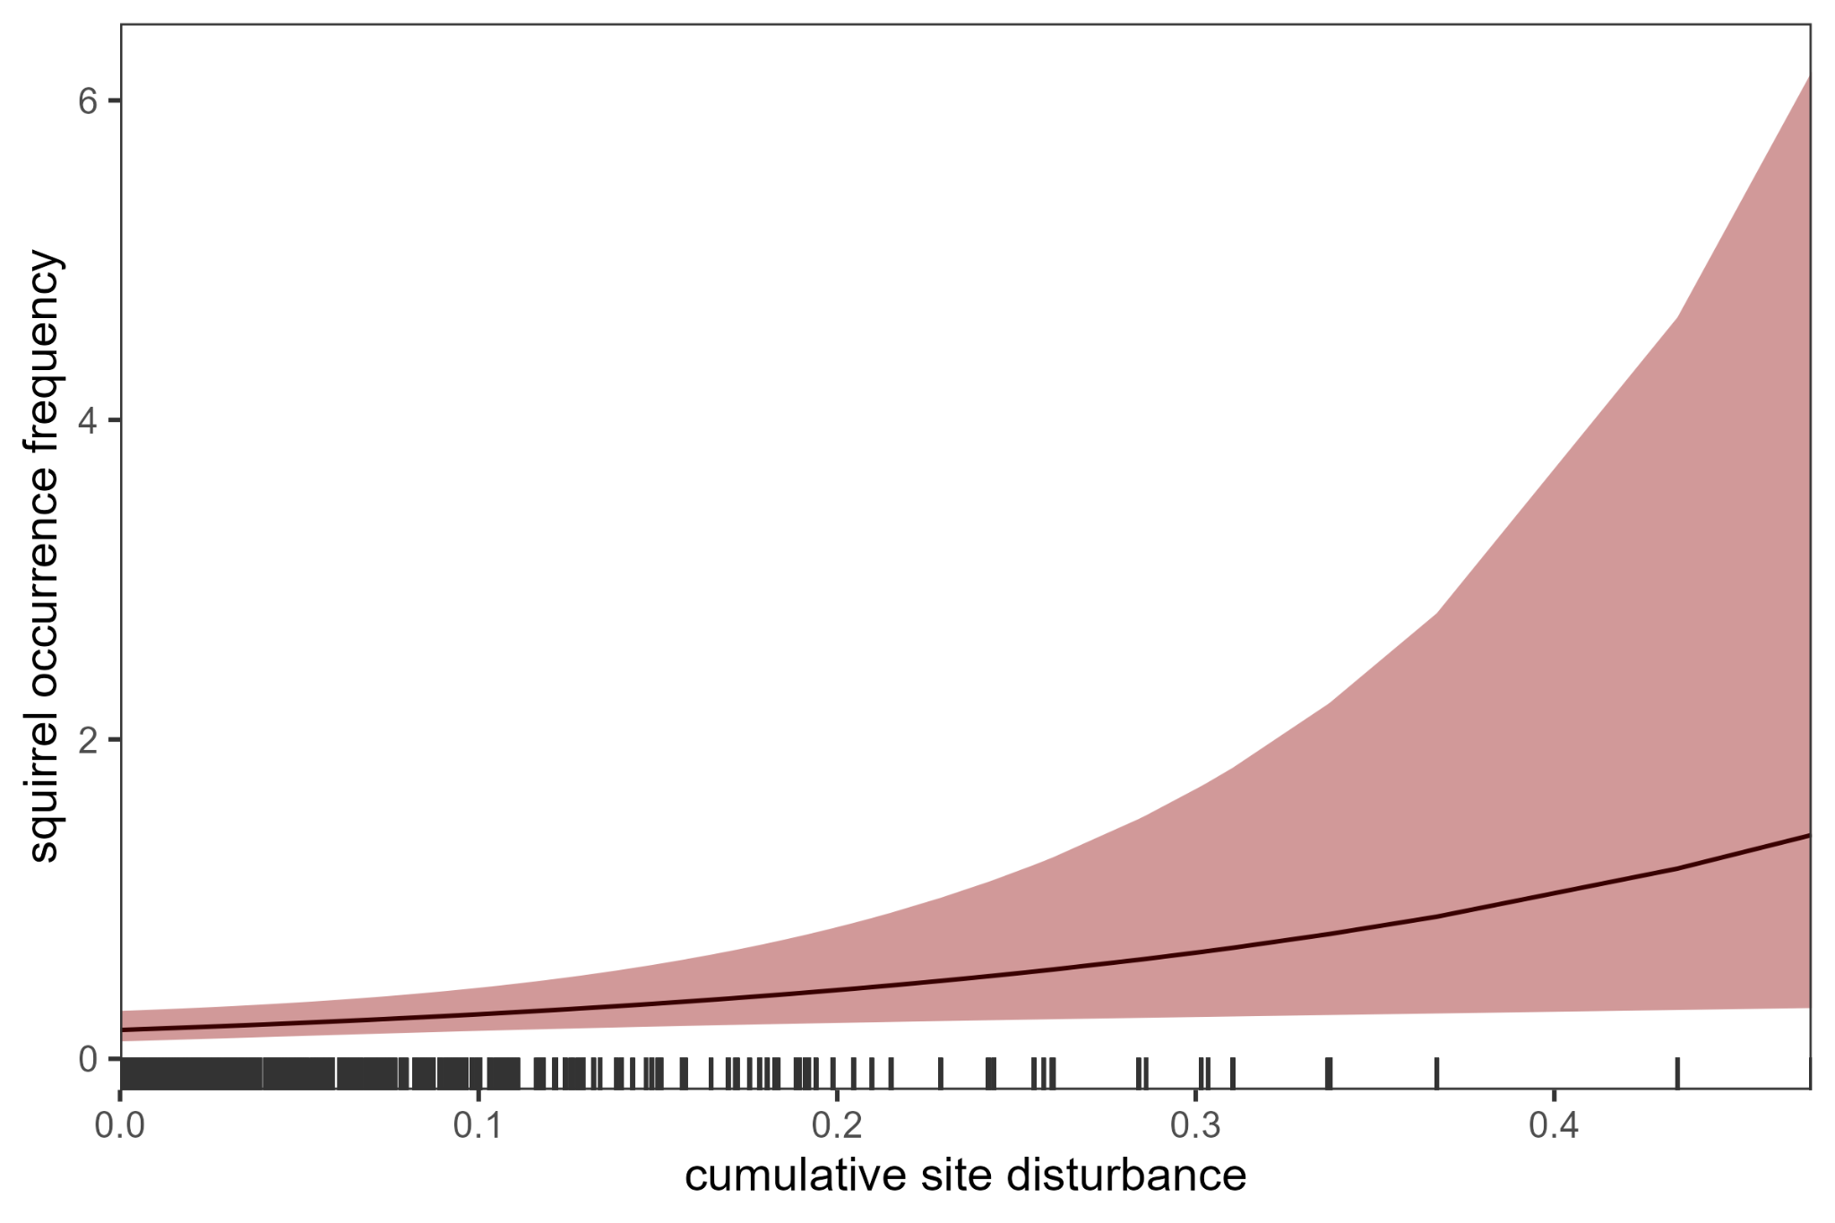
Figure 7. Conditional effect of cumulative site disturbance on red squirrel detections.

6 | References
Bartoń, K. (2024). MuMIn: Multi-Model Inference_. R package version 1.48.4,
<https://CRAN.R-project.org/package=MuMIn

